Instructions how to Set Out Profiles
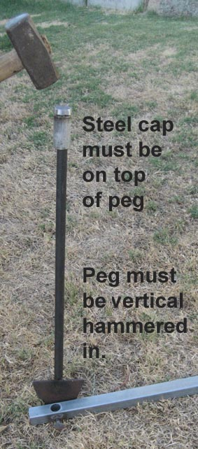
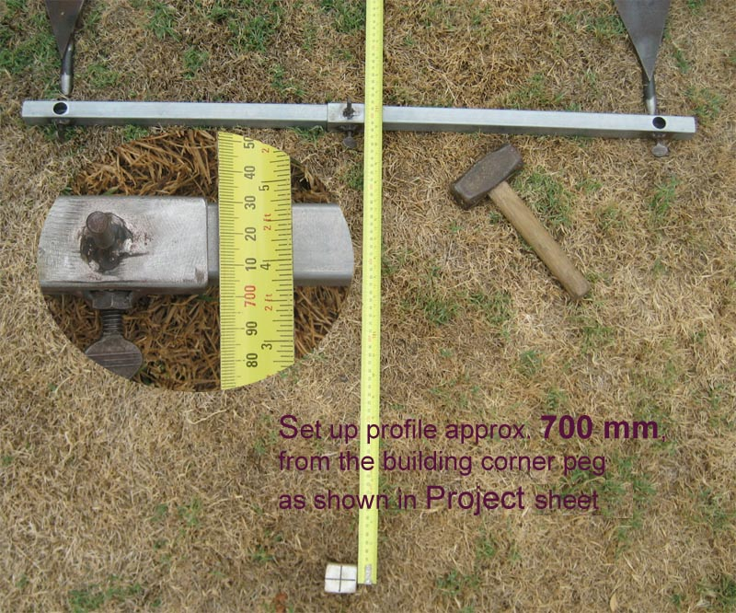
These instructions are for our new easy adjustable steel profile sets. Follow the instruction below to set out buildings.
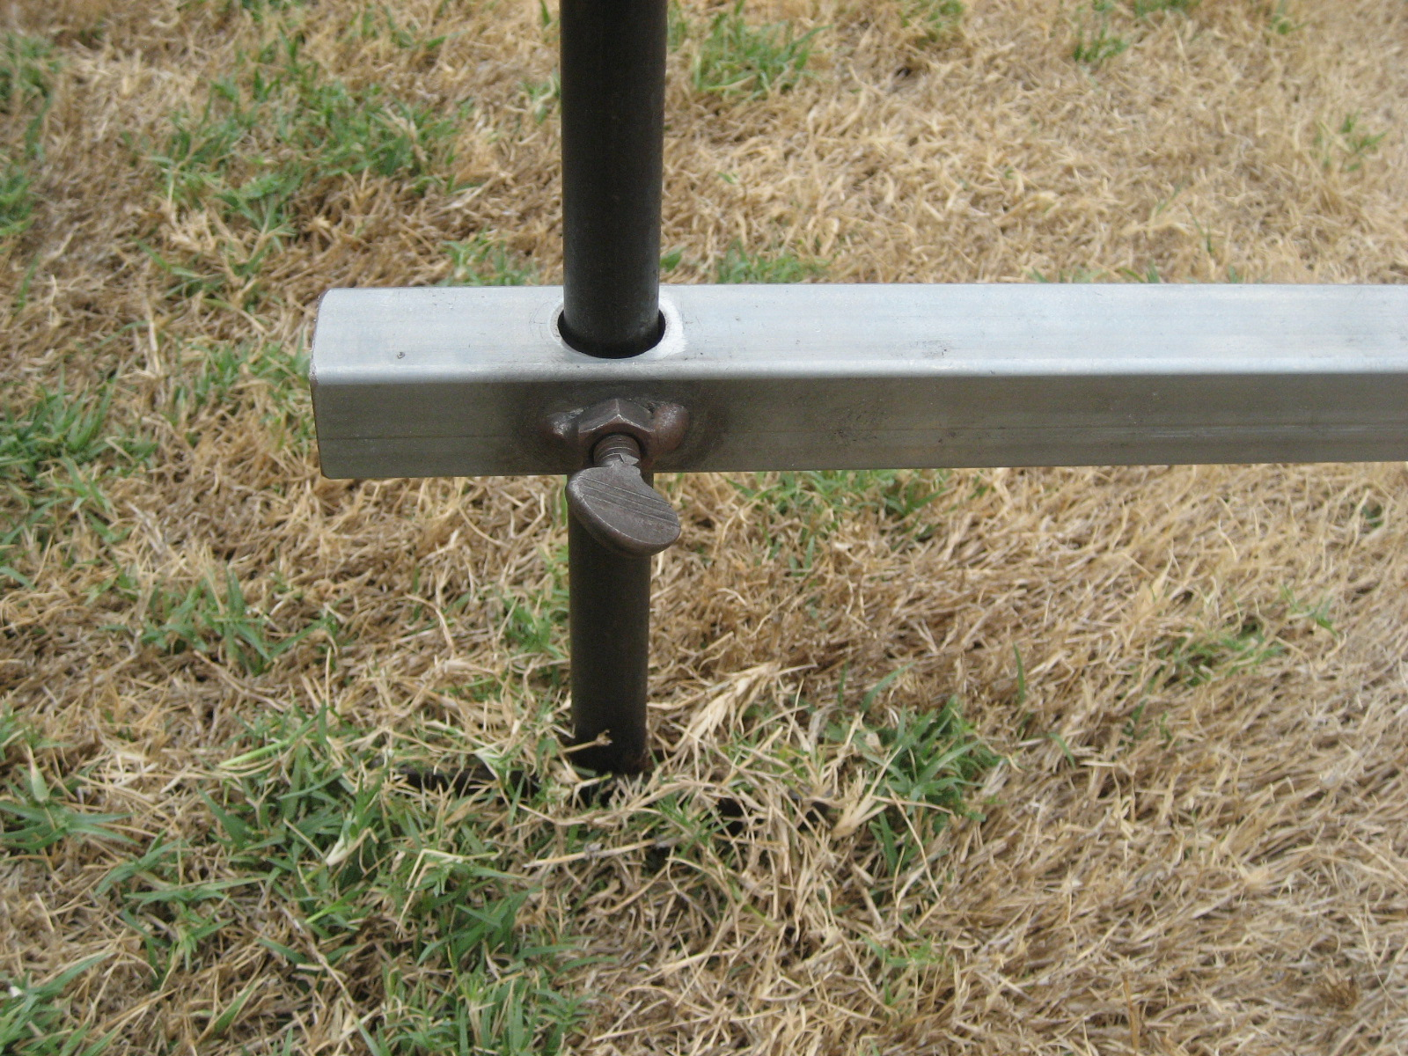
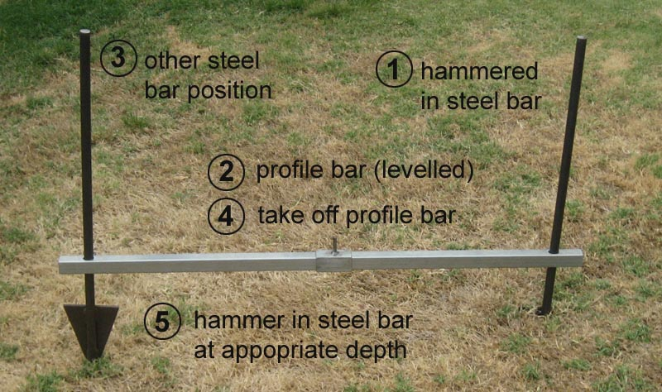
- Roughly peg out all corners of the building.
- Lay the steel profile bar approx. 700 to 1000 mm from a corner peg parallel to the building line.
- Align the round steel bars with the holes in the profile bar (see figure above).
- Vertical (use staff bubble) hammer one steel bar (place cap on top) into the ground to a stable depth.
- Position the other steel bar and slide the profile bar down both bars.
- Hammer in second steel bar (place cap on top) to a depth of approx. 50 mm.
- Take off the profile bar.
- Then hammer the second steel bar (place cap on top) deeper into the ground.
- Slide the profile bar down the steel bars again to the required RL.
- Secure height of profile bar by tightening the thumb screws.
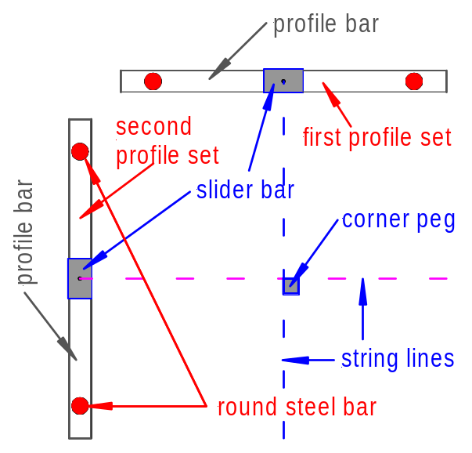

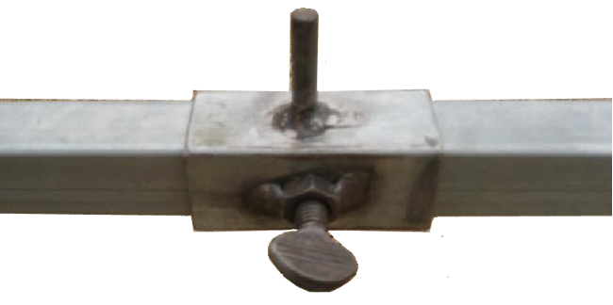As soon as first profile has been set up at one corner peg on building line, repeat this step for the second profile set to enable string line this corner peg as shown in the above left figure. Set the height of both profiles to the specified level derived from the benchmark (RL 93.670). For each corner you'll need two profile sets. Repeat these steps for all other building corners (see figure below).
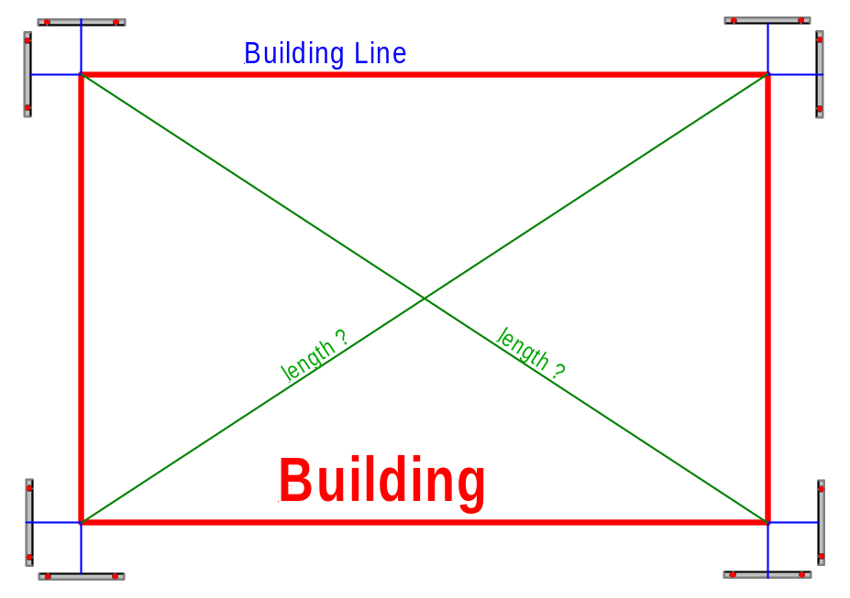

When all profiles have been set up, string the outline of the building to the required measurements. It is very important to establish a 90° angle before you do offset measures. Measure the diagonals to check whether your angles are exactly 90°
Check all dimensions and right angles of the building. Make sure all corners are at 90° and measure the diagonals to verify.
Record each step in your field notes.
When all requirements have been satisfied, please inform your lecturer. The project will be assessed in order to determine if it meets unit requirements.

